What is this document for?
The same instructions that you will read here have already been explained, and even better, by many articles online and excellent videos on YouTube.
However, this is not a simple repetition of what others have written, but a checklist that collects all the operations to be done in a single list and in the correct order.

A checklist is useful to avoid the risk of skipping any steps.
If you need more detailed and specific instructions, we recommend you follow the excellent videos of “Digital Gentiluomo” that you can find in this page.
Install Windows 11
According to Microsoft, we should throw away a lot of good PCs, many of which have fast and recent processors, but in reality you can install Windows 11 on any computer.
The only limitations are that the operating system is Windows, not Android, and that it must already be 64-bit (Home or Pro doesn't matter), that the processor is at least Dual Core, that it is not a Snapdragon ( video ), that there are at least twenty or thirty GB free on the disk and that the RAM is at least 6 GB.
We have tested this system on a large number of PCs, Notebooks, Tablets and MiniPCs of different models and on all of them it worked well and even a little faster than Windows 10, with all the drivers in place and, very importantly, they all update automatically with Windows Update.
Furthermore, the method we illustrate also saves a lot of time, compared to the extremely slow “Upgrade to Windows 11” that Windows 10 offers you on some PCs.
In a few dozen minutes, you can get rid of the worry and the Windows 11 you get is almost identical to the Windows 10 we are used to. We will have it configured as we want and it will also be a little faster and more stable than Windows 10.
Alternative methods to install Windows 11
There are also alternative methods to Rufus that we propose in this document. One of the best involves using Flyby11 that you can find explained online, for example on this page, or manual methods like on this page.
If you use an alternative method, then jump directly to the settings, in the middle of this document,
at the page: Change username and transform it into “Local account”
How to start
Go up https://rufus.ie and download the “portable” version, which is written like this:
rufus-x.xp.exe | Portable | Windows x64 | 1.5 MB | 2024.10.21

- Check that your computer is connected to the Internet
- Run rufus.exe and confirm run as administrator
- Connect a pen drive of at least 8 GB to a USB port
- Click on the arrow to the right of the word SELECT and choose DOWNLOAD
- Press the word DOWNLOAD, choose Windows 11 and press Continue
After a long download the panel should look like the next image.
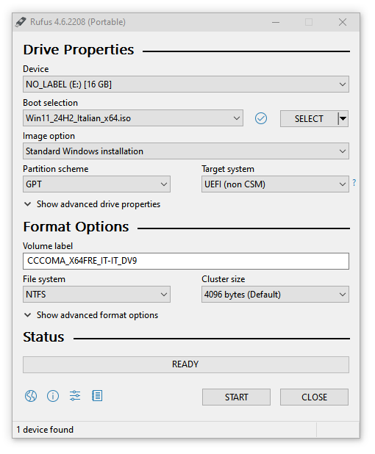

Make sure the checkboxes look like this image.

In the “Boot selection” box you should see “Win11-xxxxx-_x64.ISO”
Typically GTP, UEFI, NTFS and 4096 bytes are used.
Change these options only in special cases and only if you have a valid reason.

Finally press the START button and the image of the next page should appear.
Check the choices in the “Customize” panel
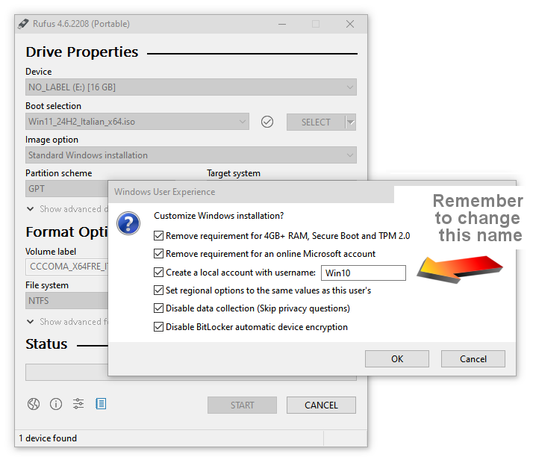

Select all the checkboxes and choose a username of your choice, it is better to call it with a neutral name, for example “User”, because after having made all the settings it will no longer be possible to change this name.
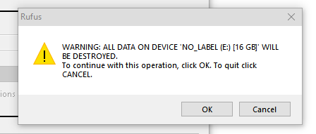
If you forget to set the name or have already written a pen drive and do not want to do it again, you can change the name at the end of the installation (but before adjusting the settings) as explained on the page “Change username and convert it to Local account”.

Make sure you do not accidentally format your system's main hard drive, SSD or other mass storage devices.
And finally press OK.
Before to use the USB stick
Before using the USB stick, you may want to go into the BIOS (which usually opens by restarting your PC and pressing DEL, F2, or ESC several times) and change some settings.
Some of the reasons could be that you want to enable Trusted computing (TPM), Security device support, or CSM, or change the BOOT from Legacy to UEFI.
Use BIOS only if there is a reason and if you know what to do, otherwise leave it as it is.

Save all important files
During installation you can choose to delete everything - which is advisable to have a system completely cleaned of old defects - or to keep your files and installed applications.
In both cases, it is advisable to copy all important data to an external hard disk, connect it to the USB, and then disconnect it.
This is because something could always go wrong and sometimes even horribly crooked. It happens very rarely but it can happen.
A good tip could also be to disconnect the Hard Disk, or SSD, and replace it with a new SSD, perhaps with more capacity. Also keep in mind that the one in use could be old and therefore sooner or later it could “get tired”.
By disconnecting the Hard Disk, or SSD, you will be safe from any possible error and you will be sure not to lose anything.
In the future, you can reconnect it to a USB connector with an adapter and, as you need them, recover any file or application.

Among the important things to save are the Drivers and the operating system Product Key.
On the next page we explain how to use two small applications to save them.
The file with the applications
We have prepared the file Windows11_Apps.zip which contains some useful applications.
- Double_Driver which is used to save the drivers
- Windows_Key_Finder which is used to read the Product Key of the operating system
These applications will be overtaken by new updates in the future, so you may want to download the latest versions from the net. In the ZIP you will also find a file to configure folder sharing: EnableGuestLogons_EXEC_AS_ADMIN_.bat
Save the drivers
Download and unzip the file Windows11_Apps.zip and then open the “Double_Driver_4.0_Portable” folder
- Then launch “dd.exe”
- Click on the “Backup” menu
- Press the “Scan Current System” button at the bottom left
- Select all the rows with the “Select” menu arrow and then “All”
- Press “Backup Now” and choose “Structured folder (default)”
- And finally press OK
It will take some time and eventually you will find the drivers in the “Double Driver Backup” folder which is located in your user “Documents” folder.
Copy the entire folder to a memory stick that you will need in the last pages of this document in case there are problems with the drivers.
Disconnect the pen drive from the PC and keep it safe for future reference.
Save Product Key
In the file Windows11_Apps.zip launch the application “Windows_Key_Finder.exe”
Select the Product Key and copy it to a text file that you will then copy to the same pen drive where you saved the drivers. Sometimes the Product Key is in the BIOS and in this case the program will not find it and it should be one of the two generic ones written below:
- Windows Home: YTMG3-N6DKC-DKB77-7M9GH-8HVX7
- Windows Pro: VK7JG-NPHTM-C97JM-9MPGT-3V66T
Boot the USB stick directly, without going into BIOS
- Connect the pen drive and open File Explorer
- Select and open the pen drive, which could probably be D or E
- Run the setup.exe file and confirm execution as administrator.
In some cases it may happen that you are unable to start with setup.exe and the installation stops with an error.
In this case we will have to boot through the BIOS as explained below.

Boot the USB stick using the BIOS
- The pen drive must already be connected to the USB
- Check that the pen drive is visible among the disk drives
- Restart your PC
- During startup, repeatedly tap the DEL key, or F2 or F10, or more rarely F12 or ESC. (depends on the PC model).
- Once you get to the BIOS, press the right arrow until you get to the penultimate menu called “Boot”
- Press ENTER to enter the menu and change the “Boot order” by placing the “CCComa_xxxxx” pen drive in first place and choosing “Partition 2”
- Press ESC to return to the top menu bar
- Press the right arrow and then ENTER to enter the SAVE menu
- Finally use “SAVE and RESTART”
Answer questions during installation
The most important choice you will be asked is whether to delete everything or keep your files and installed applications. If possible it is always better to delete everything, but In this case you need to make sure you have copied all your important data.
If you really want to do a good cleanup you should also delete all the partitions on the disk (be careful to delete the partitions on disk 0).

Language options and account name
- During installation, choose the language for the system and for the keyboard.
- When it asks “Connect to the Internet” choose “I don't have internet” which is located below in blue, otherwise Windows will force you to create a Microsoft ID.

To avoid creating a Microsoft account, sometimes “I don't have internet” might be enough, other times you might have to use the method which we explain on the next page.
But it could also happen that you have to make this damned account. In that case, don't worry, do it just to make Windows happy and then you will delete it as explained in the next pages with the title: "Change user name and transform it into Local account".

The Microsoft account
Let's be clear, the Microsoft account may also be useful and convenient, but what is wrong is that Microsoft continues to insist on forcing us to do so.
And the more they insist, the less willingly we will do it. And it is right to behave this way because it is the only way we have to teach them that using force is never okay.
When they give us the freedom to choose then we will try to use it,
otherwise they should keep it.
And this also applies to all the other options they try to force us to use, such as Office 365, News, Weather, the Store, Cortana, Copilot, etc.
Bypassing the Microsoft Account Trap
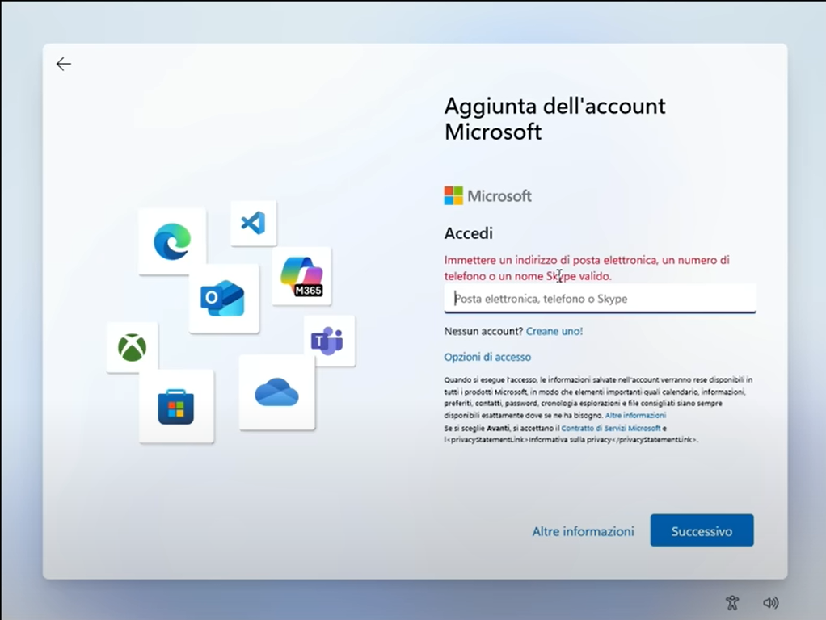
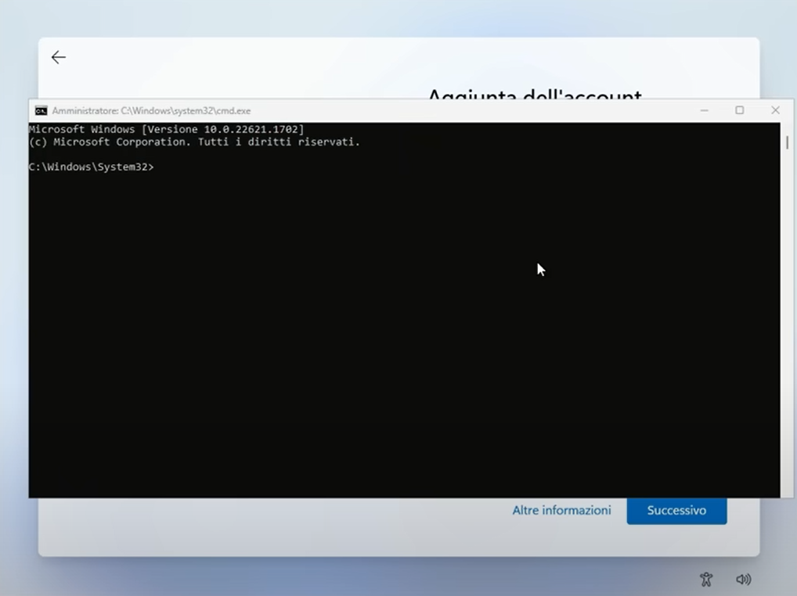
The window above leaves you no way out, it forces you to create a Microsoft account.
Luckily, even those who work at Microsoft use PCs and they also want to be able to use a local account. So they always leave some loopholes.
Then just press the SHIFT + F10 keys and the black command window you see here on the right opens.
On the next page we explain how to use it.
Bypass the trap and change to local account
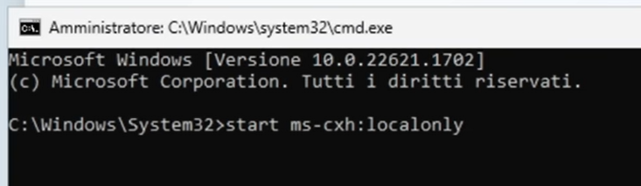

In the command window, type start ms-cxh:localonly and then press ENTER.
The classic window that allows you to create a local account will appear as seen below.
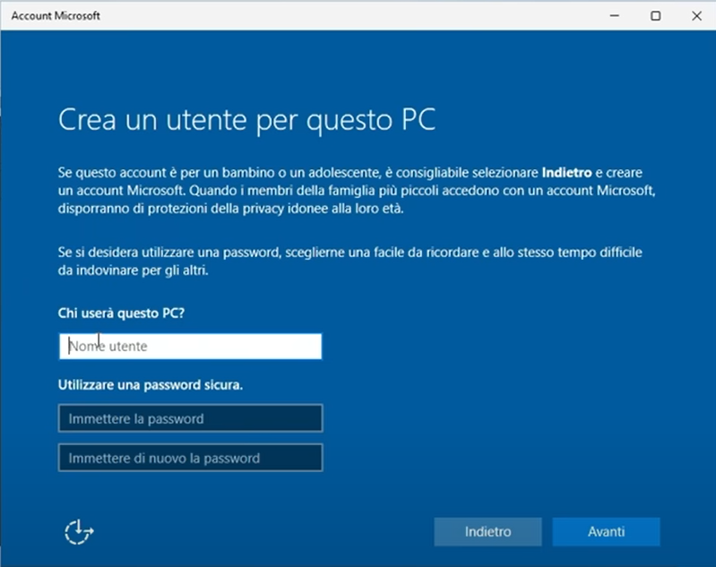
In this window, type your username.
Please note that - once you have made the settings - you will no longer be able to change it, so we recommend setting a neutral name, for example something like “User”.
You can also not enter the password and in that case it will never be asked for.
And finally press the “Next” button

Installation completion
After many minutes of messages and a number of questions (to which we recommend you always answer “no”), the installation of Windows 11 finally completes and you find yourself on the Desktop.
In the next pages we explain how to “tame” it.
The instructions we will give you are intended to have a simple system to use,
set up just the way we like it, without any stumbling blocks or annoying passwords.
But if you like passwords, accounts and lock windows, go ahead and do something different.
Change username to “Local Account”
This user switch is only useful if you have set a username in Rufus that you don't like, or if you have been forced to create a Microsoft account.
Do this as soon as you install Windows 11, because changing it will lose any settings you may have already made and you will have to redo them.
- Open “Settings”
- On the left choose “Users” (Accounts)
- Scroll down to “Other users” and press it
- Press the “Add account” button at the top right
- Do not enter email or phone number but press "I do not have this person's data"
- Do not fill in “ someone@example.com ” but press “Add without Microsoft account”
- Write the user name (we recommend a neutral name such as “User” because it can no longer be changed)
- Don't add passwords unless you're paranoid or live with werewolves who want to get into your account and spy on you.
- Press the button below and finish creating the user.
- Make the new account “Administrator” using the “Change Account Type” button
- Close the panel and restart your PC
- Upon reboot, log in with the new account you just created and then:
- Open “Settings”
- On the left choose “Users” (Accounts)
- Scroll down to “Other users” and press it
- Go to the account you want to delete and press the “Remove” button (if you fail you will have to restart again to force it to exit)

Warning: “remove everything” will make you lose all its settings, the folder with its name and its files.

So be careful to remove the right user, it must be the user you do not need and that you were forced to create with the Microsoft account.

First of all set up the Private Network
- Right-click on the network symbol (WiFi / Ethernet) at the bottom right
- Select “Network & Internet Settings”
- At the top click on the words “Properties”
- Scroll up and choose “Private network” (this way you will avoid polluting the “Public network” option with various access permissions that the various applications will inevitably ask you for over time)
- Close the panel and you're done (but if you change WiFi network you'll have to do it again)
Be aware that the network may go public on its own
This can happen whenever you press “Connect to a network” or when certain Windows updates arrive.
If you don't use folder sharing you might not even notice it.
so check often by going to “Properties” and then “Network and Internet”.
Why the network must be set to private
If you are not at the airport, or bar, or hospital, or similar, the network must always be set to “Private”.
If you don't, you are working with the public network and you won't be able to share folders.
But there's worse:
- You are working quietly in your home or in your laboratory and you think you are in a Private Network
- Every now and then a program asks you to allow it to do something on the network.
- You allow them to do so thinking that you are safe in the Private Network
- In reality, you are giving that concession to the "Public Networks"
So after a while you will have the “Public Network” which is a sieve.
And if by chance you happen to go to a “Public Network”, for example to a bar, an airport or a hospital, what do you do? Do you set up a public network that is full of permissions and does not protect you anymore?
Optimizations for Windows 11
Windows 11 is inconvenient when you first install it, it needs some fixing.
Some of these optimizations may not be important to some of you but others are essential and if you do not do them you may encounter serious difficulties and problems.
So we recommend that you at least check them all and then decide whether to do them or not.
Change PC name
- Right click on the “This PC” icon that is on the Desktop
- Select “Properties”
- At the top right, press the “Rename this PC” button
- Write your preferred name, for example “ASUS-13” or “Tablet-Kitchen”
- Press the “Next” button
- To make the new name effective, restart your PC.
Important Icons on the Desktop
- Right click on an empty part of the screen
- Select “Customize”
- In the middle of the window, press “Themes”
- Scroll down to “Desktop Icon Settings” and press it
- Enable the boxes: Computer / User Files / Network / Recycle Bin / Control Panel
- Press OK and close the “Personalization” panel
Fix Notepad
Windows 11 Notepad has been set up in an evil way and could make you lose changes what will you do to the files.
With the default settings, files open in multiple tabs and when you close Notepad with the cross in the top right, it doesn't ask you to save the files. And it didn't write the changes to disk!!!
So we recommend reconfiguring it as it was the classic Notepad:
- Open Notepad by itself or by opening a TXT file
- Select “Settings” (the cogwheel at the top right)
- Go down and change “Opening files” = “Open in new window”
- Click on “When Notepad starts” and choose “Start a new session”
- Close the notepad with the cross in the top right corner.

Taskbar Settings
- Press the right button on the bottom bar
- Choose “Taskbar Settings”
- Then, starting from the top,
- Set “Search Icon Only”
- Turn off “Activity View”
- Disable “Widgets”
- Choose (if desired) Virtual Keyboard = Always
- Click on “Taskbar Behaviors”
- Taskbar alignment = “Left”
- Remove “Show Badges”
- If necessary, remove “Select the end of the bar…”
- Close the “Personalization” panel

Power and shutdown settings
- Open the control panel
- At the top right choose “Small icons”
- Open “Power Options”
- On the left, choose “Choose what the power buttons do”
- It is recommended that you put “Do nothing” in all the boxes except perhaps the first one which might be “Shut down” on the power button.
- Then, at the top, press “Change unavailable settings”
- Scroll down and uncheck all the checkboxes (Note 1)
- Press “Save Changes”
- Then go back to the previous panel with the left arrow at the top left, and choose “Specify screen off settings”
- Choose “Never” in all boxes
- Press “Save Changes” and close everything
Note 1
In particular, “Fast Startup” would prevent a real shutdown of the PC, which over time would accumulate malfunctions without ever restarting from scratch. And the only advantage it would provide is a few seconds saved when restarting.
Enable folder sharing
Sharing folders between all PCs on the local network is very useful for those who regularly use multiple PCs at home or in a small business or laboratory.
Not everyone is interested in this option and it is quite a complex topic, so we have prepared a specific document called “Windows11 ShareFolders”
You can download it from this page and on the page you will find the Italian and English versions, as well as the DOC files that can be used to translate the documents into other languages.
Or you can download the Italian version in PDF with this connection direct.

Settings to avoid annoying disturbances
These settings prevent the system from issuing notifications, warnings and advertisements.
They are also useful for saving more than a GigaByte of disk space.
- Open “Settings”

- In the left vertical menu choose “System”
- Then choose the third item from the top “Notifications”
- Turn off the first line “Notifications” and turn on the second line “Do Not Disturb”

- In the left vertical menu choose “Privacy and security”
- Click on the “General” tab
- Disable all options

- In the left vertical menu, choose “Privacy and Security” again
- Click on the “Feedback and Diagnostics” tab
- Disable “Send optional diagnostic data” (you might want to leave this one on because it doesn’t slow down much and might help improve Windows)
- Disable “Tailored experiences”
- Disable “View diagnostic data”
- Delete past diagnostic data ( Delete diagnostic data )

- In the left vertical menu, choose “Privacy and Security” again
- Click on the “Activity history” tab
- Turn off “Store my activity history”
- Click on the “Clear history” button

If you want more detailed explanations we recommend this excellent video by “Digital Gentleman” which you can find in this page.

Check that all drivers are OK
Open the Control Panel and then “Device Manager”. If the list shown does not have highlighted areas and lines that begin with colored warning signs, then all the drivers are installed and working.
If not, go to the faulty driver,
- Right-click on its name and choose “Update driver”.
- Then click on “Browse my computer for drivers”
- Then indicate the folder where you keep all the drivers that you previously saved on
an external memory with the Double-Driver application, as we wrote in the first pages of this document.
- If all goes well, the driver should install without errors.
- Repeat for all drivers that are not working properly.

Finally, also check all the main functions of the PC, especially the audio system, cameras, WiFi and Bluetooth.
If something goes wrong, you will need to locate the relevant drivers, uninstall them, and then update them using the method above. And be sure to also view the currently unused drivers and uninstall everything - there are options in the menu to do that.
If you do not have the folder with the original drivers saved with Double-Driver then you will have to look for them on the manufacturer's website, but unfortunately they do not always publish them.

Finding the right drivers and replacing them is not easy, if you can't try with Snappy.

Check for a few more days that everything works well and then you will be sure to have the perfect PC with the new Windows 11.

Enable System Restore
- On the Start or in the magnifying glass at the bottom left, look for “Restore points”
- An option named “Create a restore point” will appear.
- By clicking it you will be asked to confirm and then the “System properties” panel will appear, set to “System protection”
- Click on the “Configure” button
- In the two options above enable system protection (Turn on system protection)
- Click OK to close the panel.
- Click on the “Create” button below
- Type a name for the restore point and click OK several times until everything is closed.

Create a recovery disk (repeat annually)
Once you are sure that your PC is working perfectly, it will be time to also make a backup on a recovery disk (a memory stick of at least 32 GB).
It could be useful in the future to fix your system in case something goes so horribly wrong that you can no longer fix it and in the worst cases not even start your PC.
In these cases, you will connect the recovery stick to a USB port, restart the PC and it will magically fix itself.
- Insert the pen drive into a USB port
- Open the Start or the magnifying glass at the bottom left and search for "Create a recovery drive" (Recovery Drive) and select it
- In the "Recovery Drive" window, select "Back up system files to the recovery drive" and click "Next".
- Select the USB memory and click "Next" (make sure it is the right one and that it does not contain data because it will be completely erased)
- Click "Create" to start the process (this will take a long time)
- Once the process is finished, click on "Finish", wait for the program to finish copying the files, or even better, eject the USB stick with the appropriate command and remove it.

Useful applications
To complete your Windows 11 system you may also use the following applications.
These applications are useful and safe
but they might make some changes to the system that you don't like
and which could then be difficult to eliminate.
This is especially true for WinHelper and Snappy.
So don't click all their buttons randomly,
Only use them if you know what they do and why.

- Theremino WinHelper Contains numerous Utilities and Hacks (modifications to the operating system)
- Theremino WiFi visualizes networks and helps position antennas
- Speccy provides a complete and detailed list of components and software
- HWMonitor measures temperatures, voltages and electrical powers of the system
- Snappy It is the best application for missing drivers recovery
- Rainmeter It's a good on-screen performance meter for CPU and other useful data.
- Equalizers is a list of good equalizers for audio
- Among the equalizers we recommend APO, or PEACE+APO or even FxSound which is easier to use.
These applications are all Freeware and Open Source so the sources are controllable and do not contain malware.
But be careful to download them from the site we indicate and not from other sites with strange names (always check the addresses on the browser before downloading).
Other useful applications
You may also want to take a look at the Theremino System Applications page:
https://www.theremino.com/en/applications

