Sound level meter
for control units
NP-NPM-NPGM

Instruction manual

The quality level of those measurement chains is the result of a continuous evolution of the hardware and software. We cannot completely rule out errors in the manual, we apologize. The data, figures and descriptions contained in this manual cannot be legally enforced. We reserve the right to make changes and corrections without notice.
We certify that the instruments listed below have successfully passed all the production tests and comply with the specifications, valid at the date of the test, reported in the technical documentation.

Sound level meter for NP-NPM-NPGM control units
The measurements carried out at an Accredia Calibration Laboratory are guaranteed by an uninterrupted traceability chain, which originates from the calibration of the Laboratory's first-line samples at the national metrological institute.

INTRODUCTION
The NP-NPM-NPGM SOUND METER FOR CONTROL UNITS is a semi-portable integrating sound level meter capable of performing statistical analyzes. The instrument has been designed combining economy and ease of use. The SOUND METER FOR NP-NPM-NPGM CONTROL UNITS meets the specifications of the IEC 61672-1 standard of 2002 with class 1 tolerances.
The SOUND METER FOR NP-NPM-NPGM CONTROL UNITS is an integrating sound level meter suitable for the following applications:
- Environmental noise level assessments
- Noise monitoring
With the use of the Audio Elaboration software it also allows you to perform:
- Identification and analysis of sound events,
- Complete statistical analysis with calculation of the percentile levels from L1, L5, L10, L50, L90, L 95, L99.
The measured sound levels are stored both after and after processing directly on the PC.
The NP-NPM-NPGM SOUND METER FOR CONTROL UNITS samples the sound signal 50 times per second and analyzes it in 0.1 dB classes. Calibration can be performed using an acoustic calibrator (class 1 according to IEC 60942).
The sound level meter SOUND METER FOR NP-NPM-NPGM CONTROL UNITS, it is suitable for monitoring the sound level, acoustic mapping as well as evaluating the acoustic climate with capture and analysis of sound events.
In parallel to the normal recording mode of raw sound level, the recording of post processing reports is available, at freely programmable intervals.

MICROPHONE
The ECM 8000 microphone, detachable from the rest of the measurement chain, is of the condenser type omnidirectional for environmental measurements of standard diameter equal to ½ ”. The frequency response, optimized for the diffuse field, upstream of each equalization is flat from 20 Hz to 20 kHz.
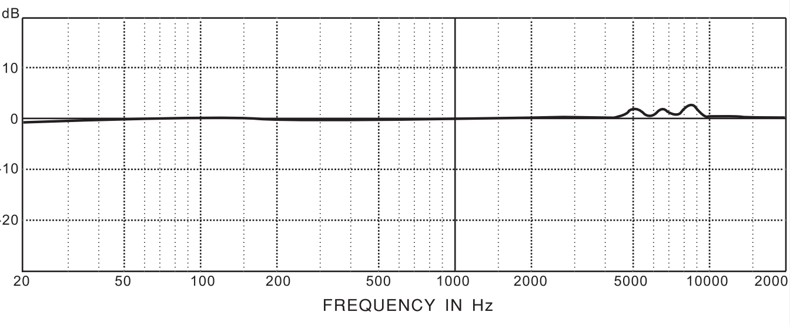

PREAMPLIFIER
The preamplifier performs the task of amplifying the weak signal provided by the supplied microphone. The XENYX preamplifier with + 48V power supply is integrated into the audio interface.
AUDIO INTERFACE
The 2x2 USB audio interface for recording from microphone with 48kHz resolution guarantees excellent audio quality and supports Windows XP or later. The power supply and connection to the PC are guaranteed by the USB port. The analog signal is converted by the interface into numerical form at 16bit. The measurement dynamics is over 60 dB as required by the reference standard. The digitized signal then reaches the mini-PC to be archived and processed.
PERIODIC CALIBRATION
The periodic calibration of the SOUND METER FOR NP-NPM-NPGM CONTROL UNITS serves to ensure its traceability to laboratory samples and is carried out in specially accredited laboratories. The NP-NPM-NPGM SOUND METER FOR CONTROL UNITS is calibrated by the Acoustics Laboratory of Metrix Enginnering before being put into use. The "factory" calibration, which is always carried out on a new instrument and every periodic calibration (at least every two years), includes the measurement of the acoustic response under pressure of the microphone-preamplifier-interface-PC complex, which is stored in the permanent memory of the pc, together with the acoustic sensitivity of the microphone.
ACOUSTIC CALIBRATION
To maintain the acoustic sensitivity of the microphone-preamplifier complex over time and in the various conditions of use, a reference sound source is used which generates a pure tone at a given frequency with a known and constant pressure level over time. For this function, class 1 acoustic calibrators are used.
Verification that the reference sound level, supplied by the acoustic calibrator, is correctly measured by the instrument (the difference in the measured sound level and the nominal sound level of the calibrator must be less than 0.5 dB) should normally be carried out before and after a series of measurements, to ensure the correctness of the measured values. When the difference between the sound level of the calibrator detected with the instrument and the nominal value exceeds 0.5 dB, it is necessary to perform a new calibration.

INSTRUMENT STORAGE
Storage conditions of the instrument:
• Temperature: -25 ÷ + 70 ° C.
• Humidity: less than 90% RH non condensing.
• In storage, avoid places where:
1. The humidity is high.
2. The instrument is exposed to direct sunlight.
3. The instrument is exposed to a source of high temperature.
4. There are strong vibrations.
5. There is steam, salt and / or corrosive gas.
The internal casing of the instrument is in plastic material; the casing of the control unit in which it is inserted is in painted metal material: do not use solvents to clean them.

TECHNICAL SPECIFICATIONS

The uncertainties refer to the temperature of 23 ° C ± 5 ° C with relative humidity

MEASURING RANGE
• Type A weighting: 40 ÷ 110dB
• Type B weighting: 40 ÷ 110dB
• Type C weighting: 40 ÷ 110dB
• Type D weighting: 40 ÷ 110dB
• Z-type weighting (linear): 40 ÷ 110dB

FREQUENCY WEIGHTING (Type A, B, C, D, Z)
• Compliant with standards IEC61672: 2002 Class 1, CNS 7129, IEC60651: 1979 Type 1, IEC60804: 2000 Type 1

MICROPHONE
• ½ "condenser microphone
• Nominal sensitivity: 13 mV / Pa
• Frequency range: 20Hz ÷ 20kHz
• Noise: <38 dB (A)

PC INTERFACE
• USB: compatible with versions 1.1 and 2.0

GENERAL FEATURES
• Linear dynamic range: 70dB
• Resolution: 0.1dB (1/1 and 1/3 octave)
• Frequency range: 20Hz ÷ 20kHz (± 0.2dB)
• Gain range: -10dB, 0dB, 10dB, 20dB, 30dB, 40dB
• Internal error: ≤ 0.1dB
• Internal noise voltage: <10 V.
• Frequency weighting: A / B / C / D / Z
• Time constants: Fast, Slow, Impulse
• Internal A / D converter: 16 bit
• Anti-aliasing filter: 22 kHz cutoff frequency, 100dB attenuation
• Integration time: customizable (from 1 min to 24 h)
• Dedicated memory: 128GBytes Flash memory

FEATURES STATISTICAL ANALYSIS
• A-weighted statistical analysis
• Integration with programmable period
• Statistical analysis with customizable period (from 1 min to 24 h)

TECHNICAL SPECIFICATIONS

CHARACTERISTICS ANALYSIS IN OCTAVE BAND AND 1/3 OCTAVE BAND
• Functions: Spectral noise analysis in octave band (1/1) and in 1/3 octave band
• Frequency weighting: A / B / C / D / Z
• Spectral analysis interface: set of spectrum frequencies
• Filter type: Hartley transform for 1/1 and 1/3 octave band analysis
• 1/1 octave analysis center frequencies: 16Hz, 31.5Hz, 63Hz, 125Hz, 250Hz, 500Hz, 1kHz, 2kHz, 4kHz, 8kHz, 16kHz
• 1/3 octave analysis center frequencies: 20Hz, 25Hz, 31.5Hz, 40Hz, 50Hz, 63Hz, 80Hz, 100Hz, 125Hz, 160Hz, 200Hz, 250Hz, 315Hz, 400Hz, 500Hz, 630Hz, 800Hz, 1kHz, 1.25kHz, 1.6kHz, 2kHz, 2.5kHz, 3.15 kHz, 4kHz, 5kHz, 6.3kHz, 8kHz, 10kHz, 12.5kHz, 16kHz, 20kHz
• Measured parameters: LXY
X = A / B / C / D / Z frequency weighting; Y = time constants adjustable from 1 to 100 Hz

GENERAL SPECIFICATIONS

Display:
• Computer with Windows operating system

Diet:
• From the USB port

Mechanical characteristics:
• Dimensions: 300 (L) x 200 (W) x 500 (H) mm
• Weight: 12.5-13.0 kg

Environmental conditions of use:
• Max altitude: 1500m
• Reference temperature: 23 ° C ± 5 ° C
• Working temperature: 5 ÷ 40 ° C
• Working humidity: <75% RH (up to 30 ° C) and <50% RH (at 40 ° C)
• Storage temperature: -5 ÷ 50 ° C
• Storage humidity: <70% RH

Reference standards:
• Statistical analysis and integration: IEC 61672: 2002 Class 1, CNS 7129 IEC 60651: 1979 Type 1, IEC60804: 2000 Type 1
• 1/1 and 1/3 octave analysis: IEC 61260: 1995 Class 1

The SOUND METER FOR NP-NPM-NPGM CONTROL UNITS uses two software:
- Theremino Audio Meter (at the time of writing this manual, version 6.8)
- Theremino Audio Elaboration (at the time of writing this manual, version 6.8)

THE SOFTWARE - AUDIO METER
The first allows the acquisition of the raw signal and the saving (with the write to file selection) in a text file with the following name with the following format xx_mm_MM_ss_tmS_YYYY in which xx is the number of frequency bands, mm is the lower limit of the first band , MM is the upper limit of the last band, ss is the scale (linear or logarithmic) tmS is the sampling time in msec, YYYY is the identification code of the control unit (e.g. 31_17,8_22400_Log_100mS_PA01.txt it is a file with 31 frequency bands with lower limit equal to 17.8 Hz and upper limit equal to 22400 Hz, logarithmic scale, 100 msec is the interval between two consecutive data series and PA01 is the name assigned to the station).
All Audio Meter controls are displayed on the left side of the screen.
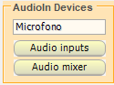
Through the “Audio In Devices” group you need to make sure that the correct input device is selected.

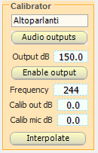
The use of the “Calibrator” group is left at the calibration center for the eventual equalization of the microphone signal. Through it it is also possible to calibrate an output device to be used for controlling the response of other measurement chains. The “Interpolate” key allows you to pass from the correction carried out on 10 bands to the corresponding one (extrapolated and interpolated) on 31 bands and vice versa.

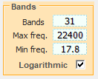
The selection of the bands is done through the group "Bands".
From the "Controls" group it is possible to set the level range displayed (from Mind dB to Max dB), the update rate of the displayed signal expressed in frequency (Decay Hz), the window function (sampling windows) and the number of samples on which the Fourier transform is performed for the spectral analysis.
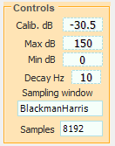
The most important item is the Calib dB item which must be adjusted using the calibrator and correcting its value until there is a correspondence between the nominal pressure level of the calibrator at the given frequency (normally 1 kHz) and the value read in correspondence with the relevant frequency.

CALIBRATION PROTECTION
In order not to inadvertently modify the calibrations, it is possible to lock the three previous panels (Calibrator, Bands and Controls).
To lock the panels in a closed position just add a password in the last line of the "Identifiers.txt" file located in the " Theremino_Files \ Identifiers " folder.

Below is an example of Audio Meter showing the calibration data.
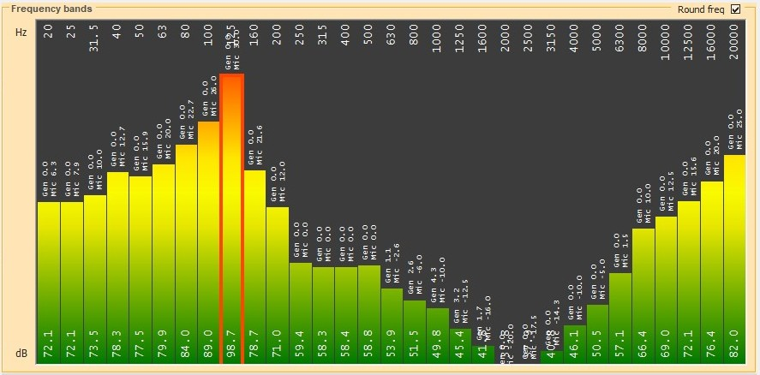

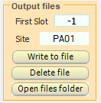
The "Output files" group allows you to set a code for the ECU, to write or delete a file and to open the folder containing the saved files.

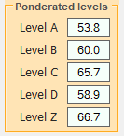
The “Ponderated levels” group displays the instantaneous values of the levels according to the A, B, C, D and Z weightings.

THE SOFTWARE - AUDIO ELABORATION
The second program, Audio Elaboration, allows the visualization and analysis of data in real or deferred time. To do this, it is necessary to select the processing start date in the “Input files” group.
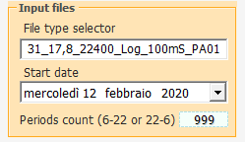
Like Audio Meter Audio Processing also displays all the controls on the left of the screen.
The File Tipe Selector box, for the correct display and processing of the data, must show the correct format as previously explained in the description of Audio Meter.
The Period count box is used to indicate to Audio Elaboration after how many periods (day and night) to interrupt the analysis, for continuous monitoring it is advisable to set its value to 999.
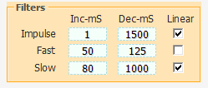
The “Filters” group specifies the time constants (both upward, Inc-mS) and downward (Dec-mS) for the calculation of the Fast, Slow and Impulse levels. It is also possible to select an exponential or linear descent.
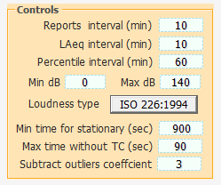
The "Controls" group Allows you to specify, in order: the time interval for returning the reports; the integration time for the A-weighted equivalent level; the time interval for extracting the percentile levels (L1, L5, L10, L50, L90, L95, L99).

Audio Processing in the central and right part of the screen can display, as desired, the time course of the Slow, Fast and Impulse levels (in the lower part) and the contents of the last reports (in the upper part) or the temporal trend of the Slow, Fast and Impulse levels (in the lower part) together with the frequency and isophonic spectrum passing through a possible tonal peak (in the upper part). The two display modes are shown below.
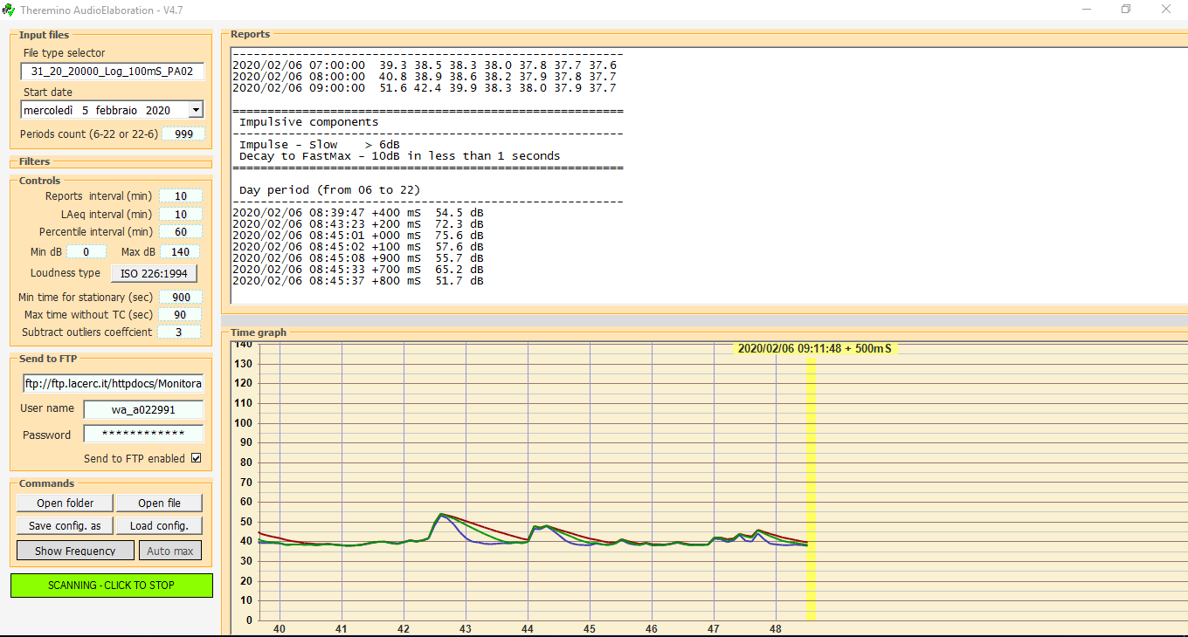
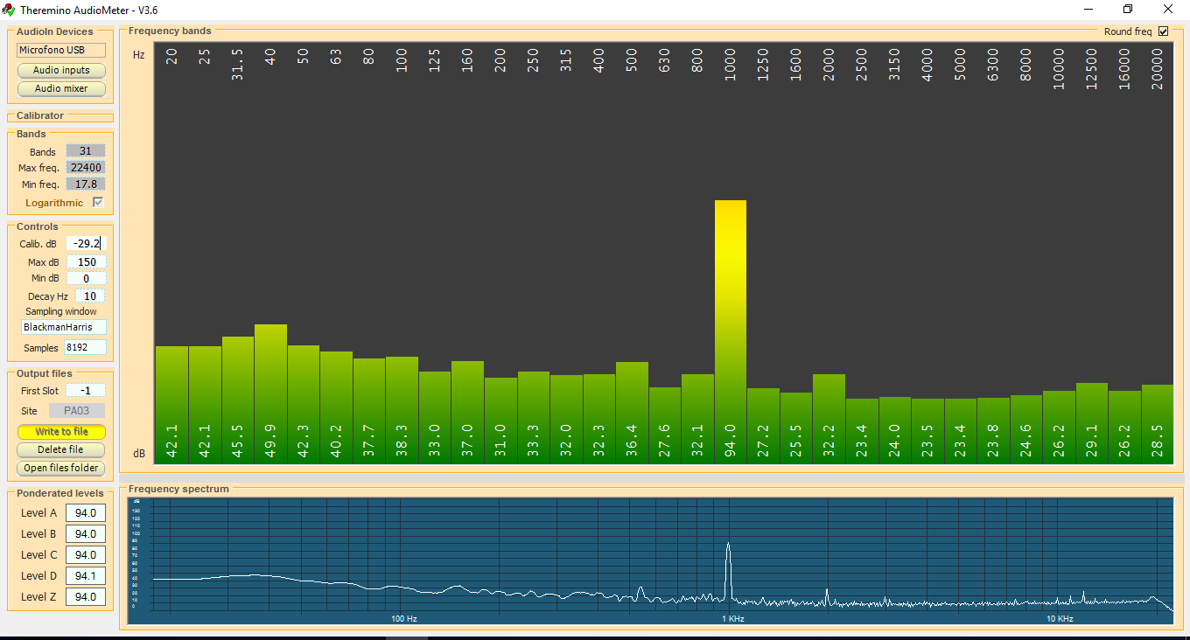
Min dB and Max dB allow you to adjust the ordinate scale in the time graph.
The "Loudness Type" button allows you to select the desired norm for the construction of the isophonics.
The "Max time for stationariety" item allows you to specify the time, in seconds, beyond which, in the case of a tonal component, the penalty of 3 dBA is to be applied. The item "Max time without TC", on the other hand, allows you to specify the minimum time for the interruption of the frequency stationarity conditions beyond which the timer for counting the stationarity seconds is reset.
The item "Subtract outliers coefficient" specifies the weighting factor of the interquartile difference used to identify any anomalous data.
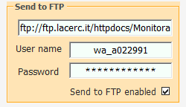
The "Send to FTP" group contains the data necessary for sending the reports generated at the end of the day period (06: 00-22: 00) and of the night period (22: 00-06: 00) to the server via FTP.

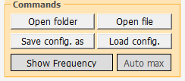
The "Commands" group contains the button for starting and stopping processing (SCANNING PERIOD / SCANNING - CLICK TO STOP) the Auto max button for automatic application of the optimal scale,

The "Load Config" button allows you to select filter settings based on literature data. "Save config", on the other hand, allows you to save your personal settings. The Open folder button allows you to open the folder containing the files to be processed while Open file opens the file being analyzed in text format.

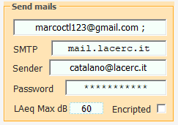
Finally, the "Send mails" group allows the sending of an alert message to addresses e-mails reported in the upper box (using the semicolon as a separator between multiple e-mail addresses) when a threshold level freely settable through the LAmax dB box is exceeded.

Setting the value to 199 dB inhibits the sending of messages. The SMTP, Sender and Password boxes must contain the sender's mail credentials.

THE SOUND METER
The sound level meter is the instrument that measures the sound level. It generally consists of a microphone, the sound-sensitive element, an amplifier, a signal processing unit and a data reading and display unit. The microphone converts the sound signal into a corresponding electrical signal. The sensitivity of the microphones for level measurements does not depend on the frequency of the sound signal. The choice of microphone type usually falls on the condenser type which offers excellent characteristics of precision, stability and reliability. The amplifier is necessary to bring the electrical signal to a measurable amplitude and to enhance the signal so as to allow its possible transmission via cable.
FREQUENCY WEIGHTINGS
If it is necessary to evaluate the auditory impact of a noise source, it will be necessary first of all to make corrections to the acoustic signal provided by the microphone in order to simulate the auditory sensation; that is, it will be necessary to correct the sensitivity of the microphone so that it depends on the frequency as it happens for the ear. Two correction curves called “A-weighting” and “C-weighting” have been defined as an international standard (IEC 60651, recently replaced by IEC 61672). When the sound level is corrected by the A-weighting it is referred to as LAp, i.e. A-weighted sound pressure level and simulates the hearing sensation for low sound levels. On the other hand, when the sound level is corrected by the weighting C it is indicated as LCp, i.e. C-weighted sound pressure level and simulates hearing sensation for high sound levels. When the auditory sensation is not interested, the measurements will be made using the Z weighting (LIN for IEC 60651) which has a constant response at all frequencies in the audio field.
TIME CONSTANTS AND EXPONENTIAL WEIGHING
Further processing of the microphone signal is necessary if fluctuating sound levels have to be measured. To evaluate a sound level that varies over time, two types of instantaneous response have been defined as an international standard (IEC 60651 / IEC 61672), one rapid, called FAST, which simulates the response of the ear, and a slow one, called SLOW, which provides a fairly stable sound level even in the case of rapidly fluctuating noises. The choice of the type of response of the level meter is combined with the choice of frequency weighting to provide a wide spectrum of possible measurement parameters; for example, the A-weighted sound level with FAST time constant (LFAp) will be measured to simulate the auditory sensation. The FAST time constant is equal to 0.125 s while the SLOW constant is equal to 1 s. When measurements are made with a FAST time constant, the instantaneous sound level will be strongly influenced by the pressure trend in the last eighth of a second, while it will depend very little on what happened more than one second before. The sound level with SLOW time constant will instead depend a lot on the pressure trend in the last second while it will be little affected by sound events that occurred more than ten seconds before. We can think that the sound level with constant SLOW is approximately an average of the instantaneous levels of the last second. The sound level with SLOW time constant will instead depend a lot on the pressure trend in the last second while it will be little affected by sound events that occurred more than ten seconds before. We can think that the sound level with constant SLOW is approximately an average of the instantaneous levels of the last second. The sound level with SLOW time constant will instead depend a lot on the pressure trend in the last second while it will be little affected by sound events that occurred more than ten seconds before. We can think that the sound level with constant SLOW is approximately an average of the instantaneous levels of the last second.

IMPULSIVE NOISES
If the sound is short-lived, it is called impulsive: for example, the knock of a typewriter and the noise of a hammer or a gun can be classified as impulsive sounds. To evaluate their impact on the auditory system, it is necessary to take into account the fact that the shorter the sound, the less sensitive the ear is in perceiving it. For this reason a time constant has been defined in the international standards (IEC 60651 / IEC 61672), called IMPULSE, very short (35 ms) for increasing sound pressure levels and very long (1.5 s) for decreasing levels.
If a sound source emits noises with a marked impulsive component, a level with a constant IMPULSE much greater than a level with a constant SLOW will be measured. The figure shows the sound level profile, measured simultaneously with FAST, SLOW and IMPULSE time constant.

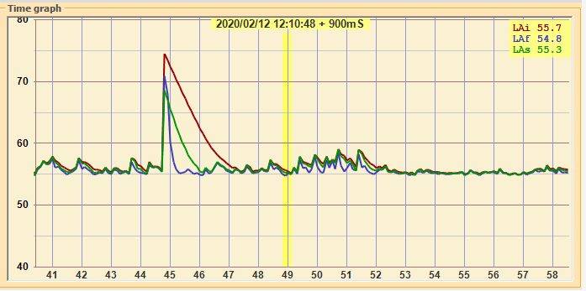

The levels displayed are maximum levels calculated on intervals equal to 1/8 s. The profile with the greatest variability is the one with a FAST time constant (8 dB), while the one with the least variability is the SLOW one (3 dB). The IMPULSE profile is systematically maintained above the FAST and SLOW profiles, denoting the impulsive characteristic of the noise emitted by the machine.
Impulsive sounds, regardless of their spectrum, are more harmful to the human ear as the energy involved, in the short period of time in which they develop, does not allow the ear to take on defenses. Therefore, at the same level there is a tendency to penalize a noise source that contains impulsive components.

THE EQUIVALENT LEVEL
The approximation of considering the levels with time constant FAST or SLOW as short-term averages is rather rough. If the sound with its propagation carries energy it is also important to take into account the duration of the sound events in order to have a correct interpretation of the energy content. This is particularly important in the evaluation of the sound impact on the hearing system, of the noise produced by machines and polluting sources in general. It is evident that a high noise causes increasing damage as the duration of exposure increases. The assessment of the harmful potential of a noise exposure will therefore be easy in the case of constant level noise. If the sound level varies over time, a measurement parameter, defined in the international standards (IEC 60804, recently replaced by IEC 61672), called "equivalent level" and symbolized as Leq. The equivalent level is defined as the constant level which has the same energy content as the fluctuating level in the time interval under consideration. The A-weighted equivalent level (LAeq) will be used to measure the energy content, and therefore the harmful potential, of a fluctuating noise source, in a given time interval.

STATISTIC ANALYSIS
If it is necessary to examine the time distribution of the sound pressure level from a statistical point of view, the measurement of the percentile levels will be used. The percentile level, symbolized as Lx, is defined as the sound level that is exceeded for the X percentage of the total time. To calculate the percentile levels, it is first of all necessary to classify the sound level sampled at regular intervals (usually 1/8 s) into classes of width usually between 0.1 dB and 2 dB. At the end of the acquisition, the probability for each class is calculated by dividing the sampling frequency by the total number of samples.

INFLUENCE OF THE ENVIRONMENT
Temperature
The sound level meters are designed to operate at temperatures between -10 ° C… + 50 ° C. The most accurate sound level meters can include thermal drift correction circuits capable of minimizing the measurement error over the entire temperature range. However, it is advisable to avoid sudden changes that can create condensation and it is also advisable to make sure that the instrument is in thermal equilibrium before carrying out a measurement or even more a calibration; to do this, it will be sufficient to wait one hour after a temperature change.
Humidity
The SOUND METER FOR NP-NPM-NPGM CONTROL UNITS with the relative microphone is not affected by relative humidity up to 85%; however, maximum protection and cleaning of the microphone must be ensured as regards rain and snow. In the event of adverse weather conditions it is advisable to use a windscreen and, in case of use in environments exposed to atmospheric precipitation, the microphone must always be kept in its housing, on the telescopic rod, protected by the supplied mesh filter.
Pressure
The sensitivity of the microphone is a function of atmospheric pressure. The sensitivity increases as the pressure decreases and the sensitivity variation for the NP-NPM-NPGM sound level meter measured at 250 Hz, is always lower than ± 0.3 dB in the 85 kPa ÷ 108 kPa range, as required by the international standard IEC 61672 for class 1 sound level meters. The sensitivity drift with ambient pressure is usually worse at high frequencies even if the maximum sensitivity difference in the 85 kPa ÷ 108 kPa range is still within ± 0.5 dB over the entire audio spectrum.
Wind
To minimize the effect of wind disturbance it is advisable to use the special windscreen, consisting of a porous sphere in polyurethane foam to be placed on the microphone. This useful accessory also serves to protect the microphone from dust, dirt in general and precipitation. The presence of the windscreen slightly alters the frequency response of the microphone at very high frequencies.
Magnetic fields
The influence of electrostatic and magnetic fields on the sound level meter is negligible.
Frequency weighting and tolerance limits
Nominal Frequency |  | Weighing |  |  | limits
Nominal Frequency |  | Weighing | dB |  | for the
Hz |  |  |  |  | class
 |  | TO | C. | Z | 1
10 |  | -70.4 | -14.3 | 0 | +3.0; -∞
12.5 |  | -63.4 | -11.2 | 0 | +2.5; -∞
16 |  | -56.7 | -8.5 | 0 | +2.0; -4.0
20 |  | -50.5 | -6.2 | 0 | ± 2.0
25 |  | -44.7 | -4.4 | 0 | +2.0; -1.5
31.5 |  | -39.4 | -3 | 0 | ± 1.5
40 |  | -34.6 | -2 | 0 | ± 1.0
50 |  | -30.2 | -1.3 | 0 | ± 1.0
63 |  | -26.2 | -0.8 | 0 | ± 1.0
80 |  | -22.5 | -0.5 | 0 | ± 1.0
100 |  | -19.1 | -0.3 | 0 | ± 1.0
125 |  | -16.1 | -0.2 | 0 | ± 1.0
160 |  | -13.4 | -0.1 | 0 | ± 1.0
200 |  | -10.9 | 0 | 0 | ± 1.0
250 |  | -8.6 | 0 | 0 | ± 1.0
315 |  | -6.6 | 0 | 0 | ± 1.0
400 |  | -4.8 | 0 | 0 | ± 1.0
500 |  | -3.2 | 0 | 0 | ± 1.0
630 |  | -1.9 | 0 | 0 | ± 1.0
800 |  | -0.8 | 0 | 0 | ± 1.0
1 000 |  | 0 | 0 | 0 | ± 0.7
1 250 |  |  | 0 | 0 | ± 1.0
1 600 |  |  | -0.1 | 0 | ± 1.0
2 000 |  |  | -0.2 | 0 | ± 1.0
2 500 |  |  | -0.3 | 0 | ± 1.0
3 150 |  |  | -0.5 | 0 | ± 1.0
4 000 |  |  | -0.8 | 0 | ± 1.0
5 000 |  |  | -1.3 | 0 | ± 1.5
6 300 |  | -0.1 | -2 | 0 | +1.5; -2.0
8 000 |  | -1.1 | -3 | 0 | +1.5; -2.5
10 000 |  | -2.5 | -4.4 | 0 | +2.0; -3.0
12 500 |  | -4.3 | -6.2 | 0 | +2.0; -5.0
16 000 |  | -6.6 | -8.5 | 0 | +2.5; -16.0
20 000 |  | -9.3 | -11.2 | 0 | +3.0; -∞

Corrections for windscreen and directivity
Frequency kHz | Windscreen correction (dB) | Acceptability (dB) | Dev.r.dir 30 ° (dB) | Acceptability (dB) | Dev.r.dir 90 ° (dB) | Acceptability (dB) | Dev.r.dir 90 ° (dB) | Acceptability (dB)
0.050119 | 0.0 | 0.5 | -0.6 | 1.0 | -1.1 | 1.5 | -1.9 | 2.0
0.063096 | 0.0 | 0.5 | -0.6 | 1.0 | -1.1 | 1.5 | -1.9 | 2.0
0.079433 | 0.0 | 0.5 | -0.6 | 1.0 | -1.1 | 1.5 | -1.9 | 2.0
0.10000 | 0.0 | 0.5 | -0.6 | 1.0 | -1.2 | 1.5 | -1.9 | 2.0
0.12589 | 0.0 | 0.5 | -0.6 | 1.0 | -1.2 | 1.5 | -2.0 | 2.0
0.15849 | 0.0 | 0.5 | -0.6 | 1.0 | -1.3 | 1.5 | -2.0 | 2.0
0.19953 | 0.0 | 0.5 | -0.7 | 1.0 | -1.3 | 1.5 | -2.0 | 2.0
0.25119 | 0.0 | 0.5 | -0.7 | 1.0 | -1.4 | 1.5 | -2.0 | 2.0
0.31623 | 0.0 | 0.5 | -0.7 | 1.0 | -1.5 | 1.5 | -2.0 | 2.0
0.39811 | 0.0 | 0.5 | -0.7 | 1.0 | -1.5 | 1.5 | -2.0 | 2.0
0.50119 | 0.1 | 0.5 | -0.7 | 1.0 | -1.5 | 1.5 | -2.0 | 2.0
0.63096 | 0.1 | 0.5 | -0.7 | 1.0 | -1.5 | 1.5 | -2.0 | 2.0
0.79433 | 0.1 | 0.5 | -0.7 | 1.0 | -1.5 | 1.5 | -2.0 | 2.0
1.0000 | 0.1 | 0.5 | -0.7 | 1.0 | -1.5 | 1.5 | -2.0 | 2.0
1.0593 | 0.2 | 0.5 | -0.7 | 1.0 | -1.6 | 2.0 | -2.2 | 4.0
1.1220 | 0.2 | 0.5 | -0.7 | 1.0 | -1.6 | 2.0 | -2.4 | 4.0
1.1885 | 0.2 | 0.5 | -0.8 | 1.0 | -1.7 | 2.0 | -2.9 | 4.0
1.2589 | 0.2 | 0.5 | -0.8 | 1.0 | -1.7 | 2.0 | -3.0 | 4.0
1.3335 | 0.2 | 0.5 | -0.8 | 1.0 | -1.9 | 2.0 | -3.0 | 4.0
1.4125 | 0.2 | 0.5 | -0.8 | 1.0 | -1.9 | 2.0 | -3.1 | 4.0
1.4962 | 0.2 | 0.5 | -0.8 | 1.0 | -1.9 | 2.0 | -3.1 | 4.0
1.5849 | 0.2 | 0.5 | -0.8 | 1.0 | -1.9 | 2.0 | -3.2 | 4.0
1.6788 | 0.2 | 0.5 | -0.8 | 1.0 | -1.9 | 2.0 | -3.3 | 4.0
1.7783 | 0.3 | 0.5 | -0.8 | 1.0 | -1.9 | 2.0 | -3.4 | 4.0
1.8836 | 0.3 | 0.5 | -0.8 | 1.0 | -1.9 | 2.0 | -3.5 | 4.0
1,9953 | 0.3 | 0.5 | -1.0 | 1.0 | -2.0 | 2.0 | -3.6 | 4.0
2.1135 | 0.3 | 0.8 | -1.0 | 1.5 | -2.0 | 4.0 | -3.8 | 6.0
2.2387 | 0.3 | 0.8 | -1.0 | 1.5 | -2.3 | 4.0 | -3.9 | 6.0
2.3714 | 0.3 | 0.8 | -1.1 | 1.5 | -2.3 | 4.0 | -4.0 | 6.0
2.5119 | 0.4 | 0.8 | -1.1 | 1.5 | -2.4 | 4.0 | -4.1 | 6.0
2.6607 | 0.4 | 0.8 | -1.1 | 1.5 | -2.4 | 4.0 | -4.2 | 6.0
2.8184 | 0.4 | 0.8 | -1.1 | 1.5 | -2.4 | 4.0 | -4.3 | 6.0
2.9854 | 0.4 | 0.8 | -1.1 | 1.5 | -2.4 | 4.0 | -4.4 | 6.0
3.1623 | 0.4 | 0.8 | -1.1 | 1.5 | -2.5 | 4.0 | -4.5 | 6.0
3.3497 | 0.4 | 0.8 | -1.2 | 1.5 | -2.6 | 4.0 | -4.6 | 6.0
3.5481 | 0.4 | 0.8 | -1.2 | 1.5 | -2.7 | 4.0 | -5.0 | 6.0
3.7584 | 0.4 | 0.8 | -1.3 | 1.5 | -2.9 | 4.0 | -5.3 | 6.0
3.9811 | 0.4 | 0.8 | -1.3 | 1.5 | -2.9 | 4.0 | -5.7 | 6.0
4.2170 | 0.4 | 0.8 | -1.4 | 2.5 | -3.0 | 7.0 | -6.0 | 10.0
4.4668 | 0.4 | 0.8 | -1.5 | 2.5 | -3.0 | 7.0 | -6.3 | 10.0
4.7315 | 0.4 | 0.8 | -1.5 | 2.5 | -3.5 | 7.0 | -6.6 | 10.0
5.0119 | 0.4 | 0.8 | -1.6 | 2.5 | -3.5 | 7.0 | -6.9 | 10.0
5.3088 | 0.4 | 0.8 | -1.7 | 2.5 | -3.9 | 7.0 | -7.1 | 10.0
5.6234 | 0.4 | 0.8 | -1.7 | 2.5 | -3.9 | 7.0 | -7.3 | 10.0
5.9566 | 0.5 | 0.8 | -1.8 | 2.5 | -4.0 | 7.0 | -7.3 | 10.0
6.3096 | 0.5 | 0.8 | -1.9 | 2.5 | -4.2 | 7.0 | -7.3 | 10.0
6.6834 | 0.5 | 0.8 | -1.9 | 2.5 | -4.3 | 7.0 | -7.3 | 10.0
7.0795 | 0.5 | 0.8 | -2.0 | 2.5 | -4.4 | 7.0 | -7.3 | 10.0
7.4989 | 0.5 | 0.8 | -2.1 | 2.5 | -4.6 | 7.0 | -7.3 | 10.0
7.9433 | 0.5 | 0.8 | -2.1 | 2.5 | -4.8 | 7.0 | -7.3 | 10.0
8.4140 | 0.5 | 1.0 | -2.3 | 4.0 | -5.0 | 10.0 | -7.4 | 14.0
8.9125 | 0.6 | 1.0 | -2.3 | 4.0 | -5.2 | 10.0 | -7.5 | 14.0
9.4406 | 0.6 | 1.0 | -2.5 | 4.0 | -5.5 | 10.0 | -7.5 | 14.0
10,000 | 0.6 | 1.0 | -2.8 | 4.0 | -5.5 | 10.0 | -7.5 | 14.0
10.593 | 0.6 | 1.0 | -2.8 | 4.0 | -6.0 | 10.0 | -7.5 | 14.0
11.220 | 0.7 | 1.0 | -3.0 | 4.0 | -6.0 | 10.0 | -7.5 | 14.0
11.885 | 0.7 | 1.0 | -3.0 | 4.0 | -6.0 | 10.0 | -7.5 | 14.0
12.589 | 0.7 | 1.0 | -3.2 | 4.0 | -6.5 | 10.0 | -7.5 | 14.0
13.335 | 0.7 | 1.0 | -3.2 | 4.0 | -6.7 | 10.0 | -7.5 | 14.0
14.125 | 0.7 | 1.0 | -3.3 | 4.0 | -7.0 | 10.0 | -7.5 | 14.0
14.962 | 0.7 | 1.0 | -3.5 | 4.0 | -7.0 | 10.0 | -7.5 | 14.0
15.849 | 0.8 | 1.0 | -3.5 | 4.0 | -7.0 | 10.0 | -7.5 | 14.0
16,788 | 0.8 | 1.0 | -3.6 | 4.0 | -7.6 | 10.0 | -7.5 | 14.0

