
theremino System
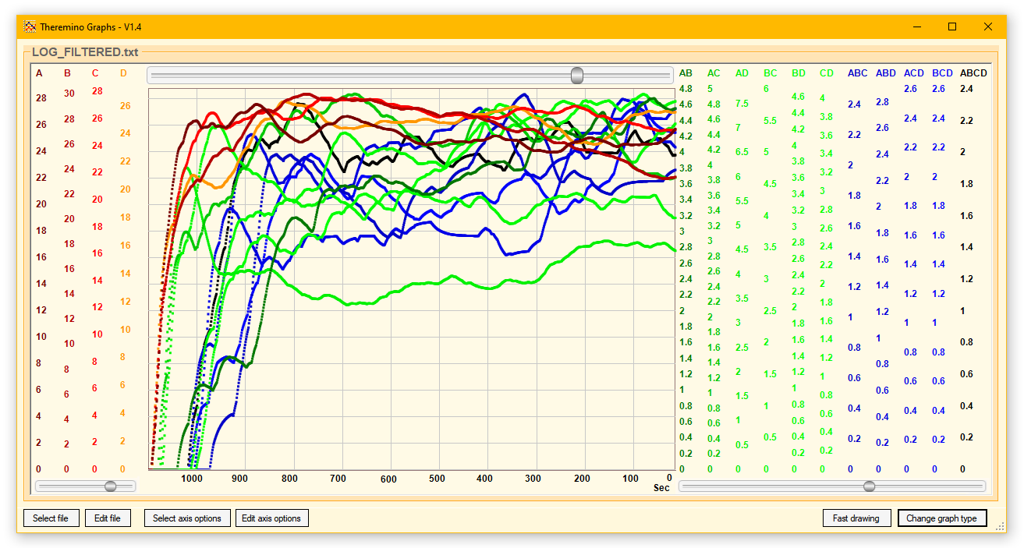
Theremino
Graphs
The Theremino Graphs application

This application displays all kinds of LOG files but if it is in the Cosmic Ray Detector you will find it already set to display those produced by Theremino FilterFIR
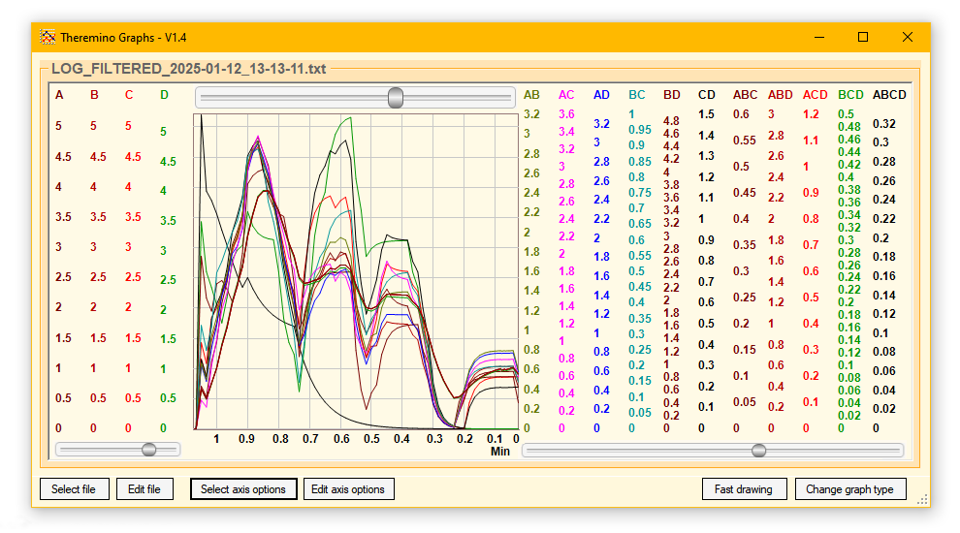
The commands are few and intuitive:

Select file - Select the file to view
Edit file - Opens the selected file with Notepad to explore it
Select axis options - Selecting the display options file
Edit axis options - Opens the options file (see next page)

Fast drawing - Makes viewing faster for very large files
Change graph type - Change display mode (lines, small or large squares)

If this application is in the Cosmic Ray Detector you will find some sample options files already ready.
If you want to create more options files use the button Select axis options and inside the folder that opens use the button to save the files.
Then give a meaningful name to the new file, save it and finally modify the options lines as explained on the next page.
The options window
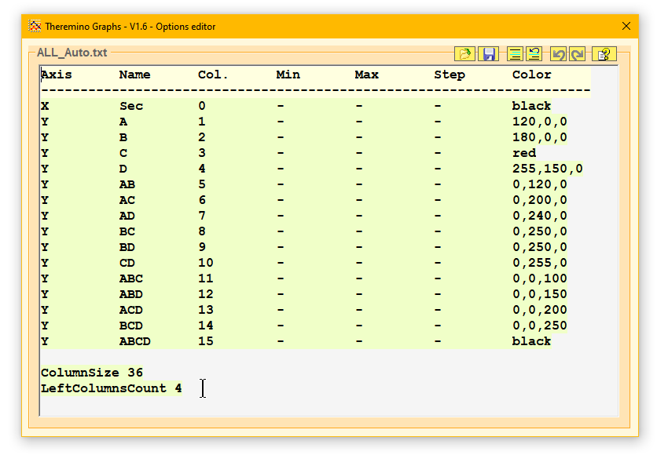
By changing these option lines you can immediately see the result on the chart.

If you experiment, it would be a good idea to first save the options file under a different name, using the button Save.
If you make mistakes you can easily go back by pressing the two keys CTRL + Z
If you then want to go back to the changes (if you have not made any changes) you can use the CTRL + Y keys

Instead of CTRL+Z and CTRL+Y you can use the two buttons Undo and Redo. which are located on the top bar.
With two other buttons you can comment on single lines or groups of lines.
The instructions for the options, in Italian and English, open by pressing the button which is located at the top right, as shown in the next image.
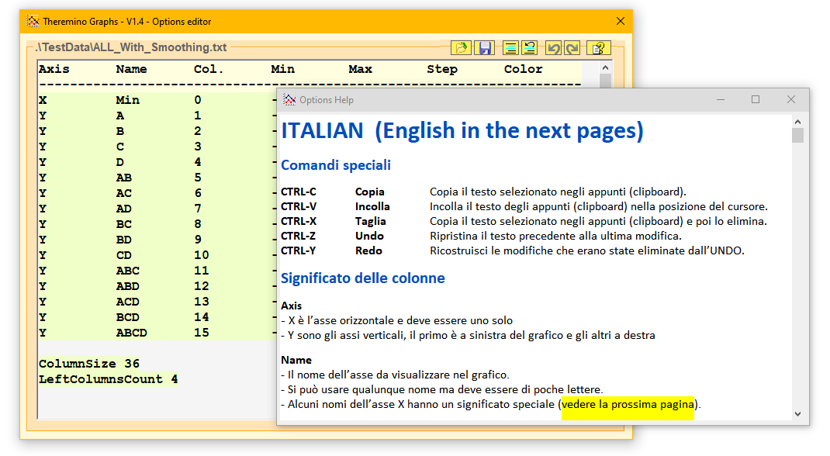
The ways of viewing

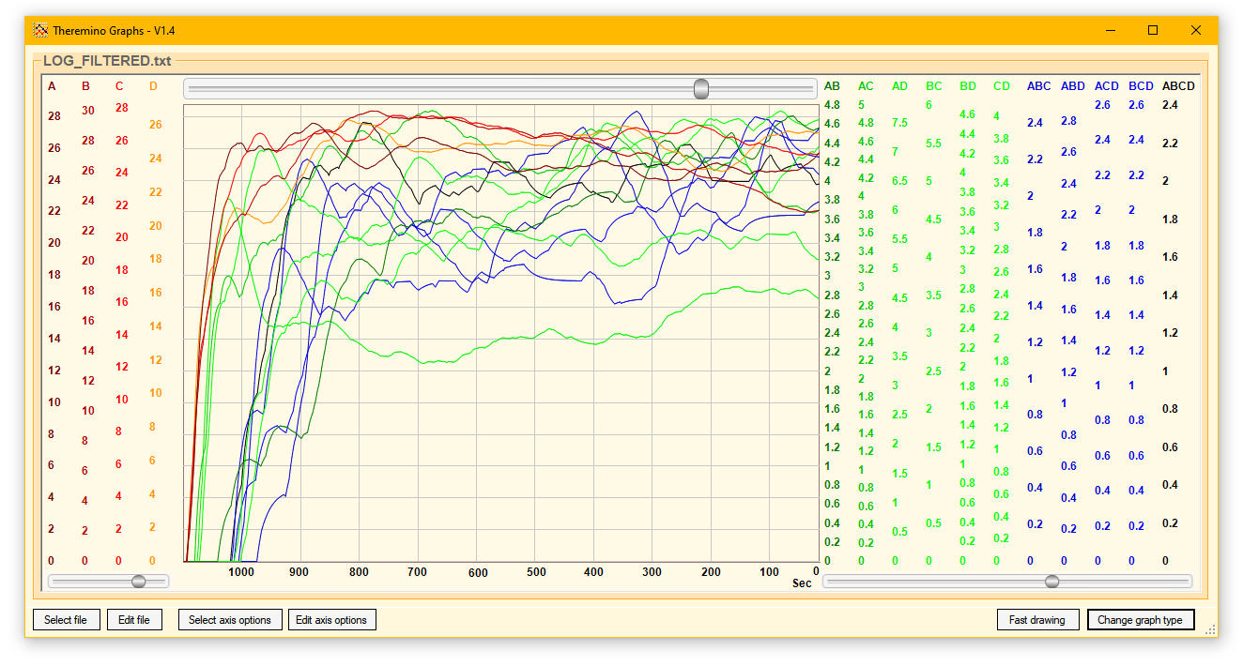
With the button Change graph type you get the three ways of displaying these images.
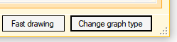
The first way, with thin lines, is more suitable when the data is limited in number.

Pressing the button multiple times switches the display between the three currently available modes.

The two-way thick lines are made up of individual squares that become a continuous line only when you have a lot of data.

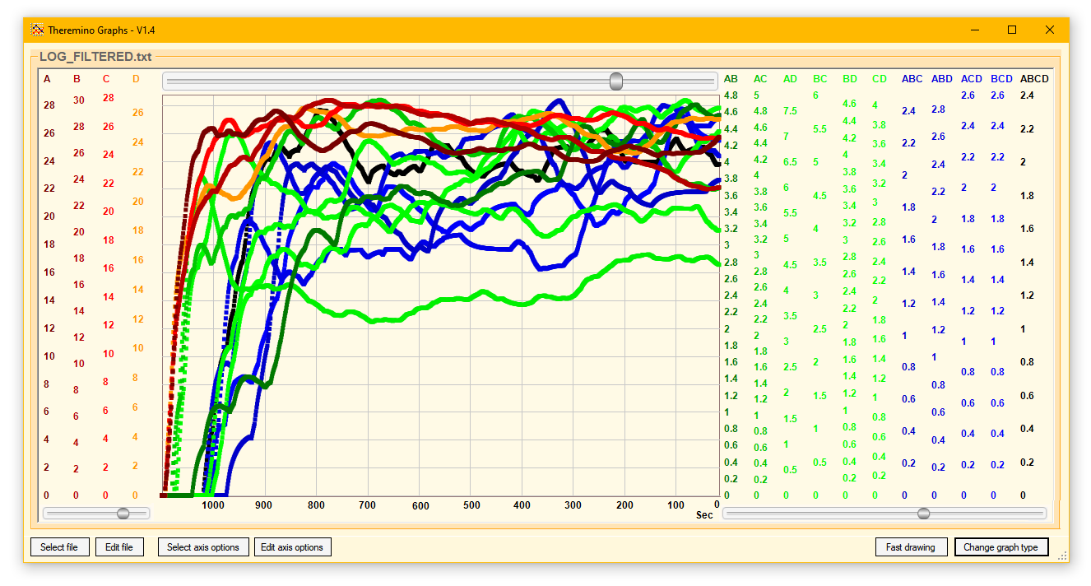
The two thick-line modes are preferable in some cases.

Experiment which one is best for you by repeatedly pressing the button.

If the file is very large, the second of the three views
may slightly increase the refresh rate.
Highlight individual curves

By moving the mouse cursor closer to the curves in the graph, they are highlighted one by one.
If you find them difficult to spot because they are too crowded, you can also highlight them by moving the mouse over the vertical axes to the right and left of the graph.

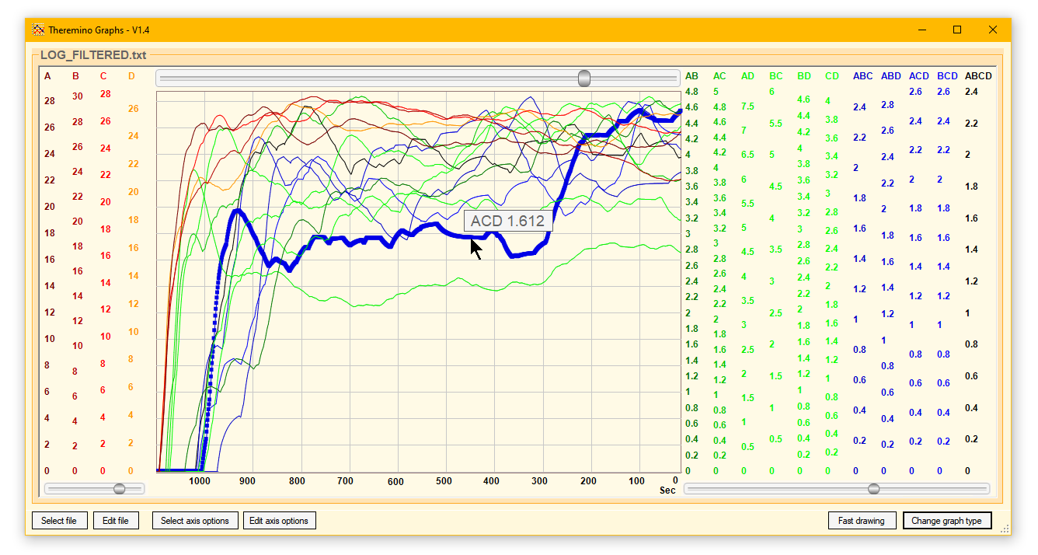
Regardless of the display mode, all curves are drawn with thin lines and medium-sized squares are also added to the highlighted one.

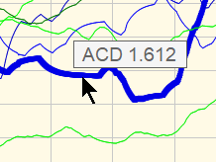
In addition to the highlighted curve, a rectangle also appears showing the name of the curve and its value at the point indicated by the mouse.

Indicate the axes with the mouse

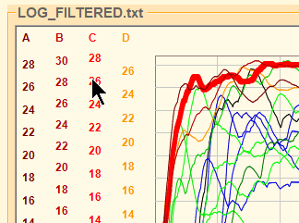
You can also highlight the curves by moving the mouse cursor over the areas of vertical stairs.
Each vertical scale starts at the top with the name of the axis and continues vertically with labels indicating the values of the scale.
To highlight an axis you can indicate any point in this vertical column.

Read date and time

By moving the mouse cursor to the lower area, on the horizontal scale, a rectangle appears showing the date and time when that particular sample was recorded.
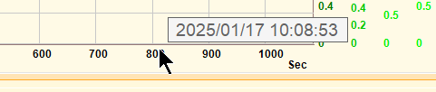

The date and time are extracted from the individual lines of the LOG file so the LOG file must contain them and be composed appropriately.

Each line of the LOG file must start with date and time in the format:
Year/Month/Day Hours:Minutes:Seconds
As in this example:
2025/01/17 10:09:07; 24.0; 25.9; ...
After the date and time there is a semicolon to separate it from the data and the following data will also be separated with semicolons.

The top scroll bar
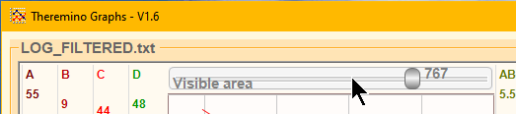

The top bar appears only if the X (horizontal) axis is time and is used to define the time dimension of the visible part of the file.
This bar contains values ranging from 1 to 1000 and are thousandths of the number of lines in the file.
When you move the bar all the way to the left, the portion of the file that is displayed will be minimal (a few dozen seconds or minutes).
When you move the bar all the way to the right you get to see the entire file.
In all cases, the rightmost value displayed is the latest data added to the file.
If the fileit is updated in real time so the data on the right is relative to the present moment.
As you move the bar you can see on the horizontal scale at the bottom how long the displayed part of the file is.
The time scale unit is automatically changed to seconds, minutes, hours or days, depending on the time dimension of the displayed part.
The two lower scroll bars
These two sliders adjust the smoothing value for the vertical axes data located on the left and right of the chart.
Remember that in the display options explained on the first pages of this document it is possible to define how many axes should be on the left and how many on the right.
And always in the display options it is also possible to swap the rows relating to the axes to change the order in which they are displayed from left to right.

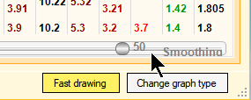
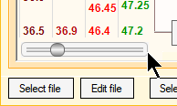
The adjustment values ​​of these sliders can range from 1 to 100.
- If you set the smoothing value to one then averaging is not performed.
- The higher the smoothing value, the more rapid variations are smoothed out.
However, one should not overdo it because otherwise the time it takes to approach the real value becomes too long.
In previous versions, smoothing options had to be written numerically in the options and it was more difficult to adjust them just right.
Since version 1.6, with the scrollbars, you can immediately see the effect on the graph lines and find more easily the amount of smoothing appropriate for the data you are viewing.

How Smoothing is performed
The Smoothing option performs an IIR (Infinite Impulse Response) average of consecutive series of values.
In practice, for each new value, a more or less large fraction of the difference between the previous value and the new one is added to the previously accumulated value.
So it is not a mathematical average over a fixed time, but a filter that favors the most recent values and gives less and less importance to past values.
This behavior is similar to natural filtering and has the beneficial effect of converging faster if the variations are large while preserving a good smoothing effect when the variations are small.
The tradeoff between the amount of smoothing and the time required to approximate the data is common to all filter types but IIR filters are preferable for visualizing data.

